**ESP32 Interfacing with SHARP,Force sensor and LoadCell**

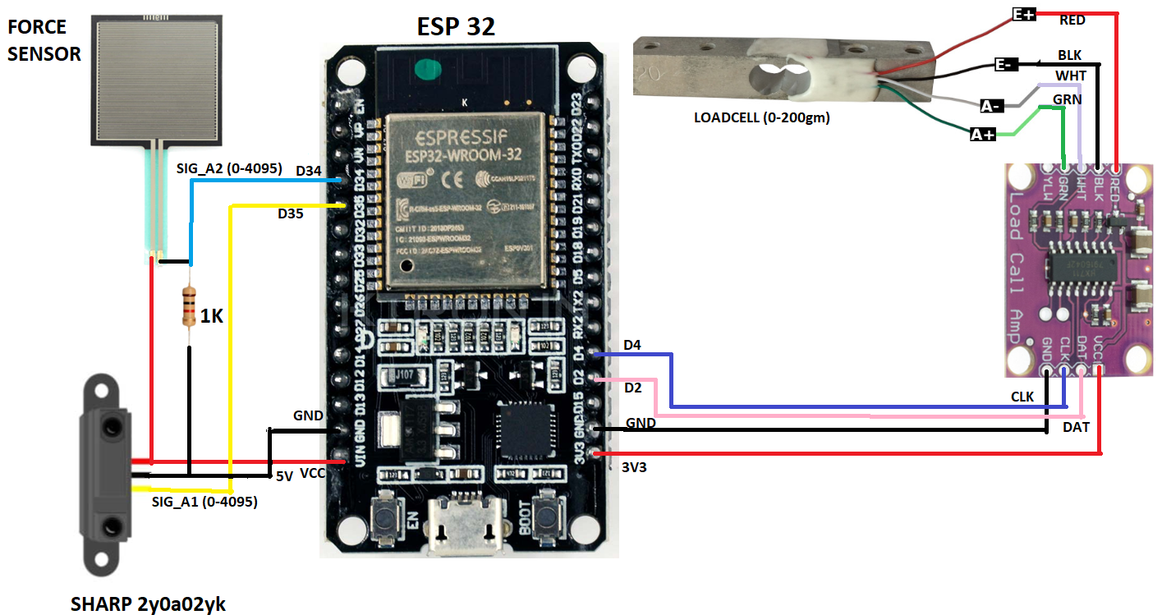

# SHARP GP2Y0A41SK0F: 4 to 30 cm

We are going to use GP2Y0A41SK0F instead of SHARP 2Y0A02YK.

<https://robu.in/product/sharp-ir-distance-measuring-sensor-unit-4-30-cm-cable/>

**Equation:**

distanceCM = 12.08 * pow(map(ir_val[NB_SAMPLE / 2], 0, 4095, 0, 5000)/1000.0, -1.058);

**ESP32 with Loadcell, SHARP IR and Force Sensor**

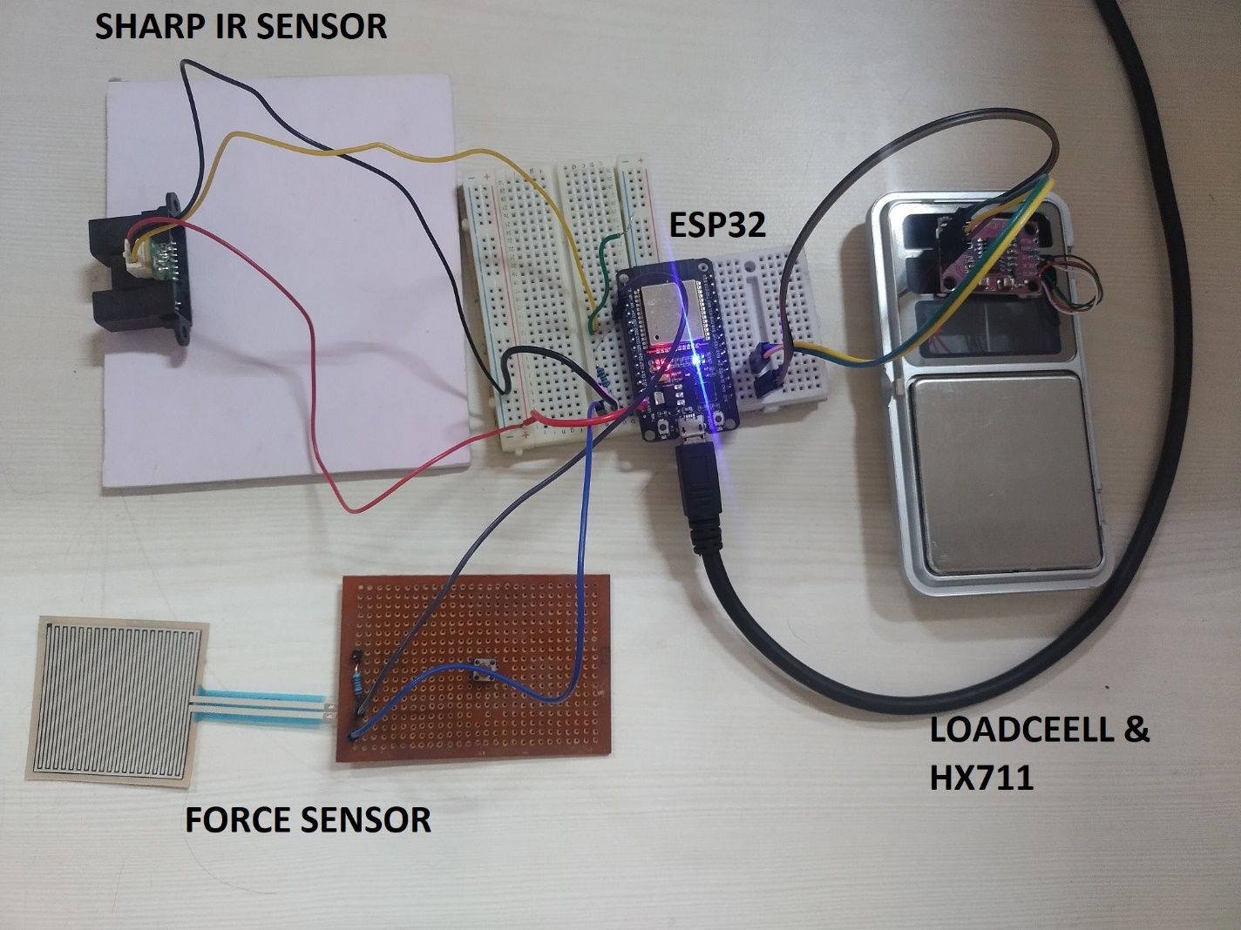

**Serial Monitor Output:**

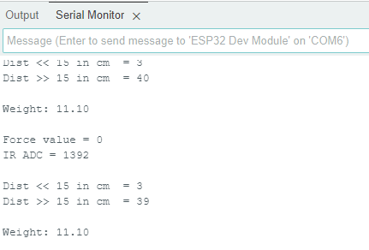





**Conveyor Belt**:

<https://robu.in/product/dobot-conveyor-belt-kit/>

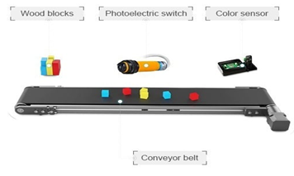

Conveyor belt homemade youtube links:

<https://www.youtube.com/watch?v=qoejrZhn5XI>

<https://www.youtube.com/watch?v=o7VVmtX7SKs>

Linear Actuator:

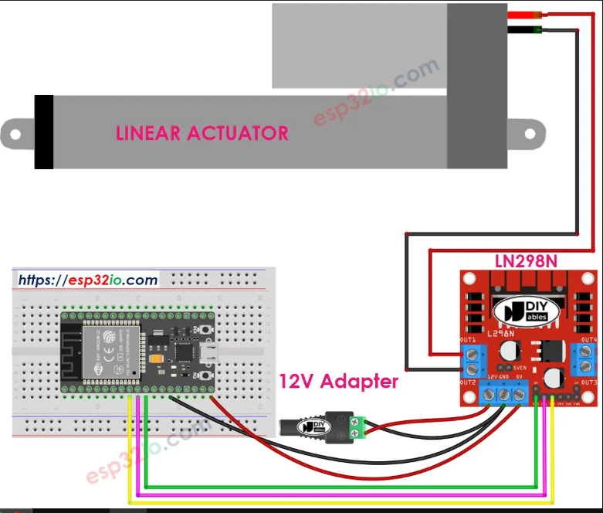

<https://robu.in/product/linear-actuator-stroke-length-100mm7mm-s1500n12v/>

<https://esp32io.com/tutorials/esp32-actuator>

